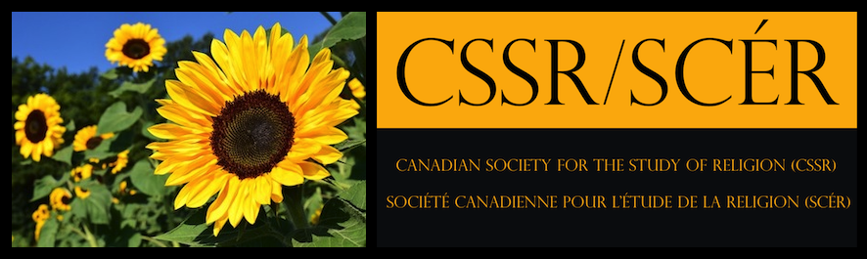

Application Form for the CSSR Student Prize:
Publicly Engaged Research in Religion
Please submit this completed form, the project file and write-up, a letter of support, and (if applicable) proof of CSSR membership. This form must be completed by each member of a group/co-authored project. Letters of support should be submitted by referees directly.

General Information
Name:
University Affiliation:
Address
(including postal code):
Email Address:
Undergraduate
Declared Major/Area:
Second Major/Area:
Minor Subject/Area:
Graduate
Degree:
Faculty:
Department/Program:
Project
Project Title:
Project Type:

Length of Write-Up (excluding bibliography and footnotes):
Project Length:
Letter of Support
Name of Referee:
Email Address:

Permission to post the winner’s name and project title

I, ________________________(name), grant non-exclusive permission to the CSSR to post my name and the title of my project on their website and social media.

Signature: _______________________________________________________ Date: _________________

